

Join communities across the United States in a national conversation on China
Tuesday, October 19
Livestream with Fareed Zakaria begins at 6:00 PM
Webinar with Morton Holbrook begins at 7:00 PM

This two part event begins with a livestream interview with Fareed Zakaria covering central aspects of the contemporary US relationship with China. This livestream will be followed by a webinar over zoom where career diplomat Morton Holbrook will reflect on the US-China relationship and answer questions from the audience.

The livestream can be found at the following URL
https://youtu.be/ccU1_waoaMQ
Or by scanning this qr code.


Register for the zoom webinar can be accessed using the URL
https://lsu.zoom.us/meeting/register/tJYlfuigrD0rHtUZRSckkhgLZ0D-haVxapGL
Or by scanning this qr code.

(Participants in the zoom webinar are required to register using their LSU credentials.)
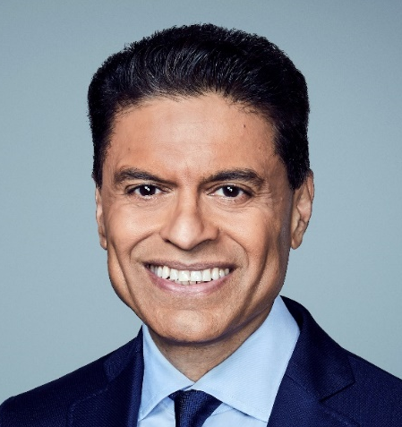

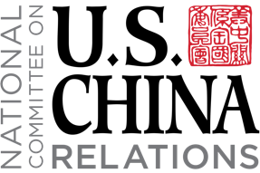


International Studies Program
Asian Studies Program
Morton Holbrook III
Career diplomat
Fareed Zakaria
Host, CNN Worldwide

