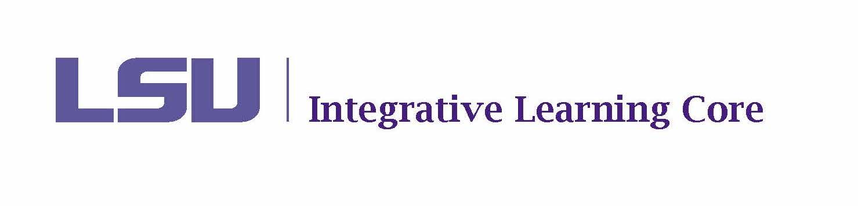

MEETING Minutes

Faculty Senate Integrative Learning Core Committee

March 10, 2025

10:30-11:30am

Meeting Location: 129 Himes Hall

Present Members: Aly Aly, Kayanush Aryana, David Chicoine (Co-Chair), Ludovico Geymonat, Kyla Kazuschyk, Selena Oswalt (Secretary), Jennifer Qian, Fanny Ramirez, Jason Wolfe (Co-Chair).

Present Ex-Officio: James Murphy, Tara Rose, Haley Bourgeois, Tricia Cobb, Tachelle White

Agenda
- Call to Order – called to order at 10:32
- Roll Call and Introductions – quorum met
- Public Comments on Agenda Items - none
- Discussion – none
- Voting
  - Minutes from February 10, 2025 – voted and approved unanimously
  - ILC Policy Updates (Renewals and Proposals) – Confirmed that the academic calendar will remain fall, spring, summer. If a course gets dropped from ILC in fall, it can still be offered in spring and summer. Voted and approved the Policy Update document unanimously.
  - Course Renewals
    - POLI 2057– Chicoine and Geymonat – voted and approved unanimously
    - ANTH 2015- Aly and Wolfe - voted and approved unanimously
  - Course Proposals
    - HNRS 2406 – Aly and Wolfe - voted and approved unanimously
  - Assessment Change Forms –
Courses must have a different assessment per dimension; some courses were using the same assessment for multiple dimensions. Tachelle reached out to the coordinators of these courses to see if they wanted to reduce the number of dimensions assessed or increase number of assessments. All chose to reduce the number of dimensions assessed. Voted and approved all assessment change forms unanimously.
    - AGRO 1001
    - BIOL 1001
    - BIOL 1002
    - BIOL 1201
    - BIOL 1202
    - HORT 2050
    - LIS 2000
    - REL 2000
  - DEI Compliance Discussion – The ILC website was flagged because of language in some proficiencies and dimensions. Civic engagement – only two courses use this proficiency and neither align to the dimension that was flagged. Global learning - 9 courses impacted because of the flagged use of the word diversity when describing cultural diversity. Intercultural - only impacted in the definition, not in the dimensions. There was a discussion about whether we should adjust the language to remove the word “diversity” or request an exemption. Under the new guidelines course titles and descriptions are not impacted. The consensus was that the descriptions for ILC should also qualify for an exemption. Voted to draft an exemption request. Approved unanimously. David will draft email, send to committee for review, and then submit.
- New Business
  - ILC Assessment Update – Tachelle will send data ahead of our next meeting for review so that we can discuss at our next meeting.
  - ILC Renewal Update – All pending renewals need to be reviewed and ready to vote at April meeting.
  - Fillable Forms Update – Jason is working on fillable pdf form rather than using a word doc. Reviewers would route the form and sign as reviews are completed.

Next meeting set for Monday April 14 10:30 – 11:30.
Adjourned at 11:11.

*It is intended that public comments may be made (1) when they relate to a matter on the agenda and (2) when individuals desiring to make public comments have registered at least one hour prior to the meeting by emailing facultysenate@lsu.edu. When registering, individuals should identify themselves; the group they are representing, if appropriate; and the topic on which they would like to comment. To ensure that the meeting is conducted in an efficient manner, each individual will be limited to 3 minutes for their public comments and the President reserves the right to limit the total number of public comments if necessary.
The LSU Faculty Senate or its Committees may meet in executive session as authorized by La. R.S. 42:17.

